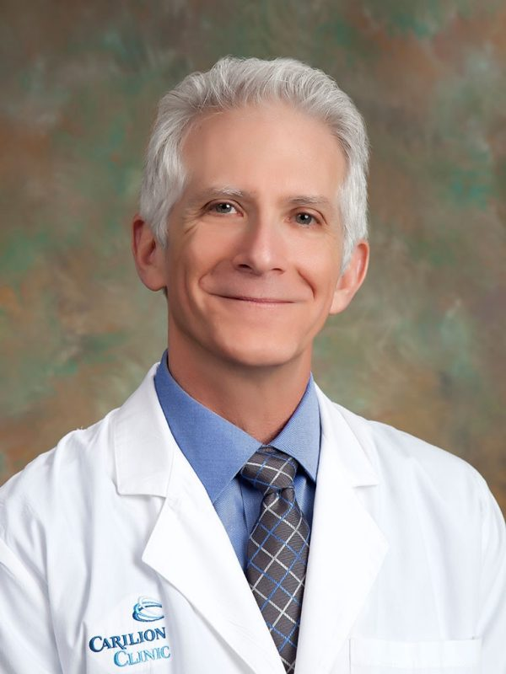

Robert L. Trestman, PhD, MD

Chair, Psychiatry and Behavioral Medicine

540-981-8597  
[**rltrestman@carilionclinic.org**](mailto:rltrestman@carilionclinic.org)  
[**Experts @ VT profile**](https://experts.vt.edu/23475-robert-trestman)

2017 S Jefferson St, 2nd Floor  
Roanoke, VA  24014

Education and Training

* University of Tennessee: MD
* Mount Sinai Medical Center, N.Y.: Internship and Residency
* University of Tennessee: PhD
* Carnegie Mellon University: BS

Other Positions

* Senior Vice President and Chair of Psychiatry, Carilion Clinic
* Professor, Psychiatry and Behavioral Medicine, Virginia Tech Carilion School of Medicine

Robert Lee Trestman, Ph.D., M.D., joined Carilion in April 2017 as Chair of Psychiatry. Dr. Trestman is a nationally recognized expert in psychiatry and population health and has an extensive background in education and research.

Dr. Trestman previously was a tenured professor of Medicine and Psychiatry at the University of Connecticut School of Medicine, with a joint appointment as professor of Nursing. He served as executive director of Correctional Managed Health Care (CHMC), a division of the University of Connecticut Health Center. In this role, he led a health system that provided global health care to all inmates within the Connecticut Department of Correction. Prior to that, he served in numerous academic and leadership roles at the University of Connecticut, Mount Sinai Medical Center, and the Bronx Veterans Affairs Medical Center.

Robert Lee Trestman PhD MD joined Carilion Clinic and the Virginia Tech Carilion School of Medicine in April 2017 as Professor and Chair of Psychiatry and Behavioral Medicine. Dr. Trestman has lectured and consulted nationally and internationally, authored or coauthored over 180 peer reviewed articles, book chapters, and commentaries.

Dr. Trestman is the Chair of the American Psychiatric Association’s Council on Healthcare Systems and Financing, is a Board member of the American Hospital Association, serves as the Liaison between the American Hospital Association and the APA and is Councilor to the American Association of Chairs of Departments of Psychiatry. He chaired the 2023 APA Workgroup on the Future of Psychiatry. He serves on the Board of the Bradley Free Clinic in Roanoke VA and is Chair of its Behavioral Health Committee. Dr. Trestman sits on the Western Virginia Division of the US District Drug Court as Expert Medical Consultant.

Dr. Trestman enjoys cycling and competes nationally as a saber fencer. His wife, Dr. Bonnie Hennig-Trestman, competes internationally as a foil fencer and has twice represented the United States at the Veterans World Fencing Championship. Between the two, they have five children.

Follow VTCSOM

[Facebook](https://www.facebook.com/VirginiaTechCarilionSOM/) [Twitter](https://twitter.com/vtcsom) [Instagram](https://instagram.com/vtcsom) [Linked In](http://www.linkedin.com/company/2337339?trk=tyah) [YouTube](https://www.youtube.com/channel/UC1Ir26hBvfpKz6L-meCWmgg)

To navigate within this website, use the breadcrumbs or the Explore bar at the top of the page.